`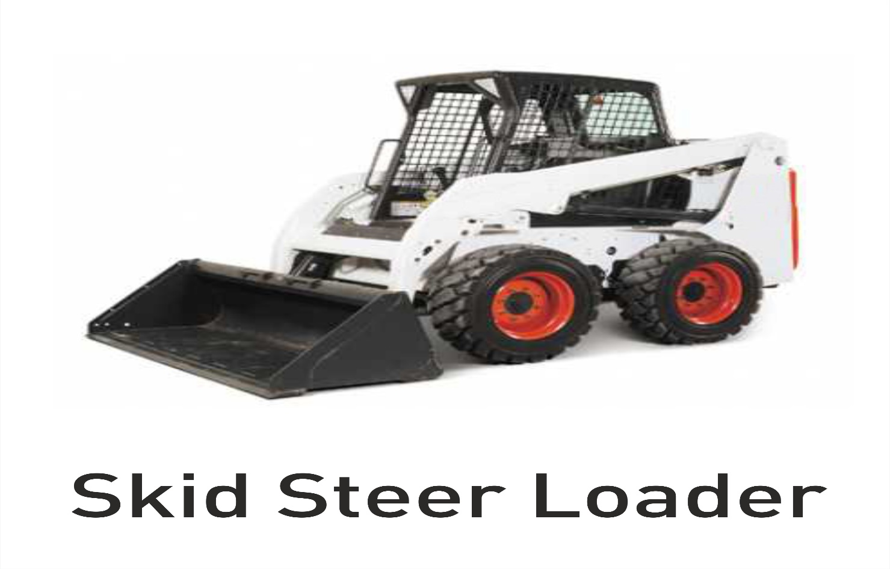
Model Curriculum

QP Name: Skid Steer loader Operator

QP Code: IES/Q0126

QP Version: 2.0

NSQF Level: 4

Model Curriculum Version: 1.0

Infrastructure Equipment Skill Council, Jubilee Building (Second Floor), No.45, Museum Road,
Bengaluru - 560025

Table of Contents

Training Parameters 3
Program Overview 4
Training Outcomes 4
Compulsory Modules 4
Module Details 5
Annexure 12
Trainer Requirements 12
Assessor Requirements 13
Assessment Strategy 14
References 15
Glossary 15
Acronyms and Abbreviations 16

Training Parameters

Sector | INFRASTRUCTURE EQUIPMENT
Sub-Sector | EQUIPMENT OPERATIONS
Occupation | SKID STEER LOADER OPERATION
Country | India
NSQF Level | 4
Aligned to NCO/ISCO/ISIC Code | NCO-2015/7233
Minimum Educational Qualiﬁcation and Experience | Class VIII
Pre-Requisite License or Training | NIL
Minimum Job Entry Age | 18 Years
Last Reviewed On | 11/01/2016
Next Review Date | 31/05/2025
NSQC Approval Date | 11/01/2016
QP Version | 2.0
Model Curriculum Creation Date | 30/04/2022
Model Curriculum Valid Up to Date | 31/05/2022
Model Curriculum Version  < | 1.0
Minimum Duration of the Course | 390 Hours
Maximum Duration of the Course | 390 Hours

Program Overview
This section summarizes the end objectives of the program along with its duration.

Training Outcomes
At the end of the program, the learner should be able to:
- Describe the controls, levers and switches in order to operate the Skid Steer Loader
- Understand all the typical occupational hazards and techniques to be overcome.
- Employ safe practices to use the tools and equipment.
- Explain the roles and responsibilities of the Skid Steer Loader Operator.
- Demonstrate the procedure to carry out all pre-use and running checks.
- Explain the importance of the right service schedule.
- Explain how to record machine running hours to determine the best service plan.
- Describe the guidelines for health, safety and security requirements.
- Prepare and maintain the logbook to keep track of all actions

Compulsory Modules
The table lists the modules and their duration corresponding to the Compulsory NOS of the QP.
NOS and Module Details | Theory  Duration | Practical  Duration | On-the-Job Training Duration (Mandatory) | On-the-Job Training Duration (Recommended) | Total Duration
Bridge Module | 4 | 0 | 0 | 0 | 4
NOS Code – IES/N 0176  NOS Name: Carry out pre-operation checks on skid steer loader  NOS Version - 2.0  NSQF Level - 4 | 25 | 46 | 0 | 50 | 121
NOS Code – IES/N 0177  NOS Name – Operate a skid steer loader  NOS Version - 2.0  NSQF Level - 4 | 25 | 50 | 0 | 50 | 125
NOS Code - IES/N 0178  NOS Name - Perform routine maintenance and troubleshooting of a skid steer loader  NOS Version - 2.0  NSQF Level - 4 | 32 | 50 | 0 | 50 | 132
NOS Code - IES/N 7601  NOS Name - Comply with worksite health and safety guidelines  NOS Version - 2.0  NSQF Level - 4 | 4 | 4 | 0 | 0 | 8
Total Duration | 90 | 150 | 0 | 150 | 390

Module Details

Module Name 1: Orientation

Bridge Module
Terminal Outcomes:
- Describe the operations of the Infrastructure Industry in India.
- Outline the skill training schemes in the Skill Sector Councils.
- Discuss the different types of job roles available in IESC.
- Explain the roles and responsibilities of the Skid Steer Loader Operator
Duration: <04:00> | Duration: <00:00>
Theory – Key Learning Outcomes | Practical – Key Learning Outcomes
- Describe the scope of employment opportunities in the industry.  - Explain the roles and responsibilities of the Skid Steer Loader Operator.  - Describe the different technical trainings conducted in SSC | NIL
Classroom Aids:
Computer, projector, printer, student table, whiteboard, flip chart, markers and duster

Tools, Equipment and Other Requirements

Module 2: Pre-op checks on Skid Steer Loader
Mapped to NOS Code – IES/N 0176 v 2.0

Terminal Outcomes:
- Explain the organization’s performance standards and procedures related to Skid Steer Loader operations.
- Explain the responsibilities of the assigned job role.
- Know the basic working of engine and all systems of the Skid Steer Loader
- Prepare and maintain a logbook to keep track of all actions.
- Understand the risks and consequences of not adhering to established processes and job instructions.
- Know the reporting structure in the organization, schedule for resolving the complaint/problem and escalation matrix for reporting unresolved problems.
- Know the emergency organization of the specific work site.

Duration: <25:00> | Duration: <46:00>
Theory – Key Learning Outcomes | Practical – Key Learning Outcomes
- List the technical characteristics, features, and performance of various types of Skid Steer Loader.  - Read and understand the guidelines in the safety and operational manual of the OEM.  - Plan work according to the required schedule and location.  - Explain the working of the controls, levers, and switches required to effectively operate the Skid Steer Loader.  - Describe the use of specialised tools provided with the machine and where the tool kit is stored.  - List the attachments for skid steer loaders and their uses.  - Describe different types of machine guards for the equipment.  - Know about all the typical occupational hazards and techniques to overcome them.  - Know about the various types of hand signals & emergency signs used on the site.  - Explain the relevance of greasing and lubrication of the Skid Steer Loader components that require routine lubrication.  - Record any deviations or occurrences that do not conform to the specified standards.  - Know the escalation matrix for reporting unresolved problems.  - List methods to enhance operational efficiency of the Skid Steer Loader | - Demonstrate the process to examine the jobsite for loose soil, concealed deep ditches, or marshy spots where the Skid Steer Loader might become trapped.  - Check the tyre inflation pressure to ensure that it meets the statutory standards/requirements of the ground.  - Test that the parking brake, main horn, reverse horn, and headlights are in good working order.  - Examine the different controls, gauges, warning lights, and other safety devices to ensure that they are working properly.  - Create a checklist for pre operation inspection of the equipment to detect damage, flaws, cracks or leaks.  - Demonstrate how visual inspection for cracks, damage, flaws, or leaks is performed before operation.  - Examine the machine for loose or missing nuts and bolts, loose guards, connectors and pivot pins.  - Check that all protection and safety devices, such as the controls locking lever, loading arm locking pin, and operator post rotation locking pin, are in the proper position according to the equipment handbook.  - Inspect bucket pins and keepers for damage and connections for leaks.  - Demonstrate how to adjust the operator’s seat, rear and side mirrors and seat belt for ease of operation.  - Demonstrate the procedure to check that the greasing points and pivots are properly greased.  - Show how to clean the air filter dust bowls and check that the gasket and inner filter are in good condition.  - Demonstrate how to drain water and debris from the fuel tank.  - Show how to check fan belt tension, battery electrolyte level and tightness of the terminals.  - Walk around the Skid Steer Loader. before starting it, to make sure no one is beneath it.  - Prepare a logbook to record all actions completed prior to starting the Skid Steer Loader.
Classroom Aids:
Computer, projector, printer, student table, whiteboard, flip chart, markers and duster
Manufacturer’s Service a n d Repair Manual

Tools, Equipment and Other Requirements
Safety Gear, Tool Kit, PPE

Module 3: Operation of a Skid Steer Loader
Mapped to NOS Code – IES/N 0177 v 2.0
Terminal Outcomes:
- Explain the responsibilities of the operator in his assigned job role.
- Explain the controls, levers and switches for proper operation of the Skid Steer Loader.
- Know how to perform all pre-use and on-the-job inspections.
- Describe the process for documenting maintenance activities in the logbook and its importance.
- Outline the reporting structure of the company.
- Outline the safety standards & procedures followed in the organization.

Duration:<25:00> | Duration:<50:00>
Theory – Key Learning Outcomes | Practical – Key Learning Outcomes
- Outline the organization’s performance standards & procedures.  - List different types of Skid Steer Loader and their applications and functions.  - Read and understand the applicable relevant aspects of the equipment operation & maintenance manuals.  - Explain the controls, levers and switches needed to operate the Skid Steer Loader efficiently.  - Communicate the general safety rules for operating a Skid Steer Loader.  - Know the cost of the equipment and loss to the Organization resulting from its damage and the direct/ indirect cost of accidents.  - Elaborate the use of the ignition switch and mechanism to start the engine in extreme cold conditions.  - Discuss the engine and hydraulics.  - Describe the instrument panel, its position, and its functionality.  - Elaborate the use of various attachments, their uses, and functions (grappler fork, buckets, side shift forks, sweepers, crane hooks, rock breaker etc.).  - Identify the tools in the tool kit and explain their use.  - Understand significance of greasing and oiling parts of the Skid Steer Loader.  - Know the optimal engine oil pressure and radiator coolant temperature.  - Identify immediate or temporary solutions to resolve mechanical issues.  - Learn common hazards in the work area and procedures to deal with them.  - Describe the risk and consequences of failing to follow clearly specified procedures/work instructions.  - List the advantages of documenting all activities/ incidents in the prescribed formats in a timely manner. | - Examine the jobsite for loose soil, concealed deep ditches, or marshy spots where the Skid Steer Loader might become trapped.  - Enter the cabin of the skid steer loader only when the engine is turned off, lift arms are down, attachments are on the ground, and the stairs and grip bars are in place.  - Ensure that the joystick controls are in neutral position before starting the skid steer loader.  - Show how to wear the seatbelt and adjust the seat position  - Demonstrate how to utilise the priming pump and pre-heater to start the engine in extreme cold weather.  - Start the engine with the starting key and test all controls, including steering, forward and backward, raising and lowering lift arms, and so on.  - Start the machine by unlocking the controls using the toggle switch located near the instrument panel.  - Describe the instrument panel, its position, and its functionality.  - Demonstrate how to adjust the machine's speed and direction in accordance with the requirement.  - Demonstrate the safe lifting/movement of the load around the site.  - Show how to test check product load in order to avoid overloading during operations.  - Show steering techniques and the proper way to steer on a slope.  - Show how to select the appropriate attachment as per the job requirement and the operation manual.  - Demonstrate how to lift and lower the bucket through foot control and pedals as per the loading / unloading requirement.  - Show how to monitor hazards and risks to ensure safety of self, other personnel, plant and equipment.  - Give examples of all signs, warnings, and other emergency signals.
Classroom Aids:
Computer, projector, printer, student table, whiteboard, flip chart, markers and duster
Manufacturer’s Service and Repair Manual

Tools, Equipment and Other Requirements
Safety Gear, Tool Kit, PPE

Module 4: Routine maintenance and trouble shooting
Mapped to NOS Code: IES/N 0178 v 2.0
Terminal Outcomes:
- Explain the responsibilities of the assigned job role.
- Communicate the reporting structure in the company.
- Show how to monitor machine working hours to determine the best service plan.
- List all the typical occupational hazards and techniques to overcome them.
- Illustrate the importance of greasing and oiling parts of the Skid Steer Loader.
Duration: <32:00> | Duration: <50:00>
Theory – Key Learning Outcomes | Practical – Key Learning Outcomes
- List parameters to be covered in the periodic maintenance sheet.  - Elaborate the fundamental mechanical system at work in the different operations of the Skid Steer Loader.  - Outline the performance standards & procedures followed in the organization.  - Define safety protocols to be observed before undertaking any repair.  - Identify common defects and general causes of breakdown.  - Outline the procedure to notify the supervisor if a fault is found that is outside the scope of the operator’s job role.  - Explain the importance of the optimal levels of control indicators e.g. fuel gauge, engine oil pressure and temperature.  - Identify the potential causes of any unusual noises coming from the engine.  - Describe importance of daily greasing of all greasing pins and pivot points. | - Create a checklist for pre operation inspection of the equipment to detect damage, flaws, cracks or leaks.  - Create daily /weekly maintenance sheets in conformance with organization recommendation.  - Carry out periodic maintenance as per the checklist.  - Demonstrate how to use appropriate props /support devices while doing maintenance.  - Demonstrate how to clean the air filter dust bowls.  - Demonstrate the procedure to check and maintain air pressure in the tyres and the tightness of the wheel nuts.  - Prepare a daily top-up plan of coolants, lubricants and fluids to ensure conformity with the manufacturer’s specifications.  - Demonstrate how to drain water and debris from the fuel tank.  - Clean the air filter dust bowls.
Classroom Aids:
Computer, projector, printer, student table, whiteboard, flip chart, markers and duster
Manufacturer’s Service and Repair Manual
Tools, Equipment and Other Requirements
Safety Gear, Tool Kit, PPE

Module 5: Health and safety
Mapped to NOS Code: IES/N 7601 v2.0
Terminal Outcomes:
- Describe the guidelines for health, safety and security requirements.
- Identify the common hazards and risks at the workshop and at site.
- Employ safe practices to use the tools and machines.
- Explain emergency procedures to stop and shutdown machinery.
- Know basic first-aid treatment for common injuries.
- Demonstrate the operation of fire-fighting equipment.
- Elaborate the procedure for storage and disposal of hazardous materials and waste.
- Design various safety signs, symbols and warnings for use in the workplace.

Duration: <04:00> | Duration: <04:00>
Theory – Key Learning Outcomes | Practical – Key Learning Outcomes
- Describe the Health, safety, environmental (HSE) policies.  - Explain the reporting procedure for all HSE activities.  - Display the contact details of HSE personnel, in case of emergencies.  - Report all health and safety related incidents/accidents.  - Explain safe working practices to avoid common hazards and risks.  - Categorize waste on the basis of non- recyclable, hazardous and recyclable material. | - Prepare a hazard log register to report incidents and accidents.  - Show the correct use of Personal Protective Equipment (PPE).  - Demonstrate safe procedure for lifting loads.  - Demonstrate the operation of fire extinguishers.  - Demonstrate how to give basic first aid.  - Conduct a mock drill for dealing with emergencies like fires and other calamities.  - Demonstrate safe storage and disposal of waste.
Classroom Aids:
Computer, projector, printer, student table, whiteboard, flip chart, marker and duster
Tools, Equipment and Other Requirements
Fire Extinguishers, Personal Protective Equipment and other safety gears

Annexure

Trainer Requirements

Trainer Prerequisites
Minimum Educational Qualification | Specialization | Relevant Industry Experience |  | Training Experience |  | Remarks
 |  | Years | Specialization | Years | Specialization
Class VIII |  | 3 | 2 | 1

Trainer Certification
Domain Certification | Platform Certification
Certified for Job Role: Skid Steer Loader Operator  Mapped to QP: IES/Q126 Version2.0.  Minimum accepted score 70%. | Certified for Job Role: Skid Steer Loader Operator  Minimum accepted score 70%.

Assessor Requirements

Assessor Prerequisites
Minimum Educational Qualification | Specialization | Relevant Industry Experience |  | Training/Assessment Experience |  | Remarks
 |  | Years | Specialization | Years | Specialization
CLASS VIII |  | 3 | 2 | 1

Assessor Certification
Domain Certification | Platform Certification
Certified for Job Role: Skid Steer Loader Operator  Mapped to QP: IES/Q126–Version2.0  Minimum accepted score 70%. | Certified for Job Role: Skid Steer Loader Operator  Minimum accepted score 70%.

Assessment Strategy

Criteria for assessment for Qualification Pack has been laid down based on the NOS’s.
Each Performance Criteria (PC) has been assigned marks proportional to its importance within NOS and weightages have also been given among the NOSs accordingly.
The assessment of the theory/knowledge will be based on written test/viva or both while skill test shall be hands on practical.
Behavior and attitude will be assessed while performing the assigned task.
The assessment shall be done as per the guidelines formulated by IESC.
The assessment agencies in consultation with IESC will create unique question papers for theory/knowledge and practical skills at each IESC accredited testing centers (as per assessment criteria below)
To pass the Qualification Pack, every trainee should score a minimum of 70%.
In case of successfully passing only certain number of NOS’s, the trainee is eligible to take subsequent assessment on the balance NOS’s to pass the Qualification pack.

References

Glossary

Term | Description
Declarative Knowledge | Declarative knowledge refers to facts, concepts and principles that need to be known and/or understood in order to accomplish a task or to solve a problem.
Key Learning Outcome | Key learning outcome is the statement of what a learner needs to know, understand and be able to do in order to achieve the terminal outcomes. A set of key learning outcomes will make up the training outcomes. Training outcome is specified in terms of knowledge, understanding (theory) and skills (practical application).
OJT (M) | On-the-job training (Mandatory); trainees are mandated to complete specified hours of training on site
OJT (R) | On-the-job training (Recommended); trainees are recommended the specified hours of training on site
Procedural Knowledge | Procedural knowledge addresses how to do something, or how to perform a task. It is the ability to work, or produce a tangible work output by applying cognitive, affective or psychomotor skills.
Training Outcome | Training outcome is a statement of what a learner will know, understand and be able to do upon the completion of the training.
Terminal Outcome | Terminal outcome is a statement of what a learner will know, understand and be able to do upon the completion of a module. A set of terminal outcomes help to achieve the training outcome.

Acronyms and Abbreviations

Term | Description
QP | Qualification Pack
NSQF | National Skills Qualification Framework
NSQC | National Skills Qualification Committee
NOS | National Occupational Standards
PMKVY | Pradhan Mantri Kaushal Vikas Yojana
QRC | Qualification Review Committee
SSC | Sector Skill Council
SDMS | Skill Development Management System
SIP | Skill India Portal
HSE | Health Safety Environment
PPE | Personal Protective Equipment

