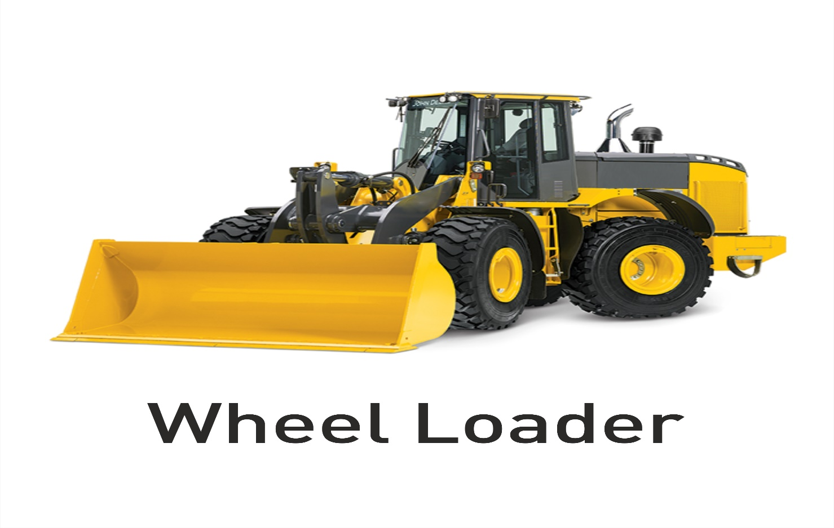
Model Curriculum

QP Name: Wheel Loader Operator

QP Code: IES/Q0105

QP Version: 2.0

NSQF Level: 4

Model Curriculum Version: 1.0

Infrastructure Equipment Skill Council (IESC), Jubilee Building (Second Floor), 45, Museum Road, Bengaluru - 560025

Table of Contents
Training Parameters 3
Program Overview 4
Training Outcomes 4
Compulsory Modules 4
Module Details 5
Annexure…………………………………………………………………………………………………………………………………………12
Trainer Requirements 12
Assessor Requirements 13
Assessment Strategy 14
References 15
Glossary 15
Acronyms and Abbreviations 16

Training Parameters

Sector | Infrastructure Equipment
Sub-Sector | Equipment Operation
Occupation | Operator
Country | India
NSQF Level | 4
Aligned to NCO/ISCO/ISIC Code | NCO-2015/7233
Minimum Educational Qualiﬁcation and Experience | Class VIII  Minimum 2 years experience in Equipment operation
Pre-Requisite License or Training | NIL
Minimum Job Entry Age | 18 Years
Last Reviewed On | 11/01/2016
Next Review Date | 31/05/2025
NSQC Approval Date | 11/01/2016
QP Version | 2.0
Model Curriculum Creation Date | 30/04/2022
Model Curriculum Valid Up to Date | 31/05/2022
Model Curriculum Version  < | 1.0
Minimum Duration of the Course | 390 Hours
Maximum Duration of the Course | 390 Hours

Program Overview
This section summarizes the end objectives of the program along with its duration.

Training Outcomes
At the end of the program, the learner should:
- Know the organization’s procedures and guidelines related to wheel loader operations
- Know the controls, levers and switches in order to operate the wheel loader properly
- Understand all the typical occupational hazards and techniques to be overcome
- Employ safe practices to use the tools and equipment
- Understand how to operate the wheel Loader for various applications
- Understand and know the different attachments options available for the machine
- Understand and know periodic maintenance, all checks and service intervals

Compulsory Modules
The table lists the modules and their duration corresponding to the Compulsory NOS of the QP.
NOS and Module Details | Theory  Duration | Practical  Duration | On-the-Job Training Duration (Mandatory) | On-the-Job Training Duration (Recommended) | Total Duration
Bridge Module | 4 | 0 | 0 | 0 | 4
NOS Code – IES/N 0113  NOS Name: Carry out pre-operation checks on wheel loader  NOS Version - 2.0  NSQF Level - 4 | 25 | 46 | 0 | 50 | 121
NOS Code – IES/N 0114  NOS Name – Operate a wheel loader  NOS Version - 2.0  NSQF Level - 4 | 25 | 50 | 0 | 50 | 125
NOS Code - IES/N 0115  NOS Name - Carry out maintenance and troubleshooting of the wheel loader  NOS Version - 2.0  NSQF Level - 4 | 32 | 50 | 0 | 50 | 132
NOS Code - IES/N 7601  NOS Name - Comply with worksite health and safety guidelines  NOS Version - 2.0  NSQF Level - 4 | 4 | 4 | 0 | 0 | 8
Total Duration | 90 | 150 | 0 | 150 | 390

Module Details

Module 1: Orientation

Bridge Module
Terminal Outcomes:
- Describe the operations of the Infrastructure industry in India.
- Outline the skill training schemes in Skill Sector Councils.
- Know about the different types of job roles available in IESC.
- Understand the roles and responsibilities of the Wheel Loader Operator.
Duration:<4:00> | Duration:<0:00>
Theory – Key Learning Outcomes | Practical – Key Learning Outcomes
- Describe employment opportunities in the industry.  - Explain the roles and responsibilities of a Wheel Loader Operator.  - Describe the different technical trainings conducted in SSC. | NIL
Classroom Aids:
Computer, projector, printer, student table, whiteboard, flip chart, markers and duster

Tools, Equipment and Other Requirements

Module 2: Pre-op checks on Wheel Loader
Mapped to NOS Code – IES/N0113 v 2.0

Terminal Outcomes:
- Explain the organization’s procedures and guidelines related to wheel loader operations.
- Explain the responsibilities of the assigned job role.
- Understand job-specific documentation and its importance such as daily maintenance checklist, operation handbook and components manual.
- Understand the risks and consequences of not adhering to established processes and job instructions.
- Know the reporting structure in the organization, schedule for resolving the complaint/problem and escalation matrix for reporting unresolved problems.
- Know the emergency organization of the specific work site.

Duration: <25:00> | Duration: <46:00>
Theory – Key Learning Outcomes | Practical – Key Learning Outcomes
- Introduction to the engine and transmission, as well as their use and purpose.  - Explain the process for adding fuel and coolant to the compactor.  - Describe the method to identify the grade and quality of oil to be used.  - Describe the working of various controls, levers, switches, instrument panel & fuse box of the machine.  - Identify various tools provided with the machine, explain their use and the importance of putting them back after use.  - Explain why the operator should walk around the wheel loader before starting it, to make sure no one is beneath it.  - Explain the importance of greasing and oiling pivots and pins that require routine lubrication.  - Explain the use of the Operator Handbook and Components Manual.  - List typical occupational hazards and techniques for dealing with them.  - Know the cost of the equipment and loss to the organization resulting from its damage and the direct/ indirect cost of accidents.  - Know the recommended optimal engine oil pressure and radiator coolant temperature.  - Read instructions, guidelines /procedures/rules related to the worksite and equipment operations.  - Explain the importance of using cabin controls and different operating modes and selection procedures and usage of the wheel loader in sequence of operation.  - Know the safety interlocks and their functions during start and stop of machine  - Know the function of the parking brake  - Explain the function of service braking system on the machine and how to check the brake disk in the wheel hub.  - Explain in the detail the importance of the latest emission norms in force since 01st Oct, 2021 and the major pollutant emissions in the exhaust gas.  - Explain the EATS system and the EGR system & functions of DOC, SCR, DPF, ASC. | - Demonstrate the process to examine the bucket cutting edge, loader’s structure and the lift mechanism for signs of excessive wear.  - Demonstrate the process to inspect the tyres, wheels, lug nuts, and stem caps for inflation, leaks and damage  - Illustrate how to inspect the tanks, transmission, axles, tilt cylinders, pipes and hoses for leaks or damage.  - Describe the process of draining moisture from air tanks in case it is equipped with air brakes.  - Demonstrate how to check the fluid and liquid levels in the engine, hydraulic tank, fuel tank, gearbox, radiator, and brakes for conformity to the manufacturer's specifications.  - Test that the parking brake, main horn, reverse horn, and headlights are in good working order.  - Examine the different controls, gauges, warning lights, and other safety devices to ensure that they are working properly.  - How to operate the wheel loader during face loading and Load & Carry Operation.  - How to switch on and off Boom Suspension System and avoid usage of load & carry operation – this is a safety procedure to be followed to prevent damage of tyres and equipment.  - Selection of various switches during operation.  - Understand the importance of not to park on the slopes of the ramp as well as mines where trucks are plying; to avoid accidents.  - Understand the location of EATS components, Ad Blue and its role in Emission control, fill quantities and the importance of reduced Ad Blue levels leading to severe inducement on the machine leading to stoppage of work at site.  - Know and identify the locations of various oil filling / drain points and identify location of all filters.  - Know in detail the maintenance functions of the wheel loader; understand the importance of preventive maintenance to reduce time.
Classroom Aids:
Computer, projector, printer, student table, whiteboard, flip chart, markers and duster
Manufacturer’s Service a n d Repair Manual

Tools, Equipment and Other Requirements
Safety Gear, Tool Kit, PPE

Module 3: Operation of a Wheel Loader
Mapped to NOS Code – IES/N0114 v 2.0
Terminal Outcomes:
- Explain the responsibilities of the assigned job role.
- Explain the controls, levers and switches for proper operation of the wheel loader.
- Know how to perform all pre-use and on-the-job inspections.
- Describe the process for documenting maintenance activities in the logbook and its importance.
- Outline the safety standards & procedures followed in the organization.
Duration:<25:00> | Duration:<50:00>
Theory – Key Learning Outcomes | Practical – Key Learning Outcomes
- List different types of wheel loaders and their applications and functions.  - Understand controls, levers and switches in order to operate the wheel loader properly.  - Communicate the general safety rules for operating a wheel loader.  - Walk around the wheel loader before starting it, to make sure no one is beneath it.  - Elaborate the use of the ignition switch and mechanism to start the engine in extreme cold conditions.  - Discuss the engine and transmission, as well as their use and purpose.  - Understand significance of greasing and oiling parts of the wheel loader.  - identify immediate or temporary solutions to resolve mechanical issues.  - Learn common hazards in the work area and procedures to deal with them.  - Describe the risk and consequences of failing to follow clearly specified procedures/work instructions. | - Show how to wear the seatbelt and adjust the seat position  - Know position and operation of the emergency stop button.  - Describe the instrument panel, its position, and its functionality.  - Demonstrate how to adjust the machine's speed and direction in accordance with the requirement.  - Demonstrate the safe movement of the load around the site.  - Show how to test check product load in order to avoid overloading during operations.  - Demonstrate turning radius of the equipment and safe operation in limited space.  - Show steering techniques and the proper way to steer on a slope.  - Give examples of all signs, warnings, and other emergency signals.
Classroom Aids:
Computer, projector, printer, student table, whiteboard, flip chart, markers and duster
Manufacturer’s Service and Repair Manual

Tools, Equipment and Other Requirements
Safety Gear, Tool Kit, PPE

Module 4: Routine maintenance and trouble shooting
Mapped to NOS Code: IES/N0115 v 2.0
Terminal Outcomes:
- Explain the responsibilities of the assigned job role.
- Communicate the reporting structure in the company.
- Show how to monitor machine working hours to determine the best service plan.
- List all the typical occupational hazards and techniques to overcome them.
- Illustrate the importance of greasing and oiling parts of the wheel loader

Duration: <32:00> | Duration: <50:00>
Theory – Key Learning Outcomes | Practical – Key Learning Outcomes
- Elaborate the fundamental mechanical system at work in the different operations of the wheel loader.  - Outline the performance standards & procedures followed in the company.  - Define safety protocols to be observed before undertaking any repair.  - Define the scope of the position and when and to whom to escalate for help.  - Identify common defects and general causes of breakdown.  - Explain the importance of the optimal levels of control indicators e.g. fuel gauge, engine oil pressure and temperature.  - Describe the importance of regular cleaning of air filter dust bowls.  - Identify the potential causes of any unusual noises coming from the engine.  - Identify prominent places on the equipment for display of safety and maintenance stickers.  - Describe importance of daily greasing of all greasing pins and pivot points. | - Create a checklist for pre operation inspection of the equipment to detect damage, flaws, cracks or leaks.  - Create daily /weekly maintenance sheets in conformance with organization recommendation.  - Carry out periodic maintenance as per the checklist.  - Demonstrate how to use appropriate props /support devices while doing maintenance.  - Demonstrate how to clean the air filter dust bowls.  - Demonstrate the procedure to check and maintain air pressure in the tyres and the tightness of the wheel nuts.  - Prepare a daily top-up plan of coolants, lubricants and fluids to ensure conformity with the manufacturer’s specifications.  - Demonstrate how to drain water and debris from the fuel tank.
Classroom Aids:
Computer, projector, printer, student table, whiteboard, flip chart, markers and duster
Manufacturer’s Service and Repair Manual
Tools, Equipment and Other Requirements
Safety Gear, Tool Kit, PPE

Module 5: Health and safety
Mapped to NOS Code: IES/N 7601 v2.0
Terminal Outcomes:
- Describe the guide lines for health, safety and security requirements.
- Identify the common hazards and risks at the workshop and at site.
- Employ safe practices to use the tools and machines.
- Explain emergency procedures to stop and shutdown machinery.
- Know basic first-aid treatment for common injuries.
- Demonstrate the operation of fire-fighting equipment.
- Elaborate the procedure for storage and disposal of hazardous materials and waste.
- Design various safety signs, symbols and warnings for use in the work place.

Duration: <04:00> | Duration: <04:00>
Theory – Key Learning Outcomes | Practical – Key Learning Outcomes
- Describe the Health, safety, environmental (HSE) policies.  - Explain the reporting procedure for all HSE activities.  - Display the contact details of HSE personnel, in case of emergencies.  - Report all health and safety related incidents/accidents.  - Explain safe working practices to avoid common hazards and risks.  - Categorize waste on the basis of non- recyclable, hazardous and recyclable material. | - Prepare a hazard log register to report incidents and accidents.  - Show the correct use of Personal Protective Equipment (PPE).  - Demonstrate safe procedure for lifting loads.  - Demonstrate the operation of fire extinguishers.  - Demonstrate how to give basic first aid.  - Conduct a mock drill for dealing with emergencies like fires and other calamities.  - Demonstrate safe storage and disposal of waste.
Classroom Aids:
Computer, projector, printer, student table, whiteboard, flip chart, marker and duster
Tools, Equipment and Other Requirements
Fire Extinguishers, Personal Protective Equipment and other safety gears

Annexure

Trainer Requirements

Trainer Prerequisites
Minimum Educational Qualification | Specialization | Relevant Industry Experience |  | Training Experience |  | Remarks
 |  | Years | Specialization | Years | Specialization
CLASS VIII |  | 3 | 2 | 1

Trainer Certification
Domain Certification | Platform Certification
Certified for Job Role: Wheel Loader Operator  Mapped to QP: IES/Q0105 Version2.0.  Minimum accepted score 70%. | Certified for Job Role: Wheel Loader Operator  Minimum accepted score 70%.

Assessor Requirements

Assessor Prerequisites
Minimum Educational Qualification | Specialization | Relevant Industry Experience |  | Training/Assessment Experience |  | Remarks
 |  | Years | Specialization | Years | Specialization
CLASS VIII |  | 3 | 2 | 1

Assessor Certification
Domain Certification | Platform Certification
Certified for Job Role: Wheel Loader Operator  Mapped to QP: IES/Q0105 - Version2.0  Minimum accepted score 70%. | Certified for Job Role: Wheel Loader Operator  Minimum accepted score 70%.

Assessment Strategy

Criteria for assessment for Qualification Pack have been laid down based on the NOS’s.
Each Performance Criteria (PC) has been assigned marks proportional to its importance within NOS and weightages have also been given among the NOSs accordingly.
The assessment of the theory/knowledge will be based on written test/viva or both while skill test shall be hands on practical.
Behavior and attitude will be assessed while performing the assigned task.
The assessment shall be done as per the guidelines formulated by IESC.
The assessment agencies in consultation with IESC will create unique question papers for theory/knowledge and practical skills at each IESC accredited testing centers (as per assessment criteria below)
To pass the Qualification Pack, every trainee should score a minimum of 70%.
In case of successfully passing only certain number of NOS’s, the trainee is eligible to take subsequent assessment on the balance NOS’s to pass the Qualification pack.

References

Glossary

Term | Description
Declarative Knowledge | Declarative knowledge refers to facts, concepts and principles that need to be known and/or understood in order to accomplish a task or to solve a problem.
Key Learning Outcome | Key learning outcome is the statement of what a learner needs to know, understand and be able to do in order to achieve the terminal outcomes. A set of key learning outcomes will make up the training outcomes. Training outcome is specified in terms of knowledge, understanding (theory) and skills (practical application).
OJT (M) | On-the-job training (Mandatory); trainees are mandated to complete specified hours of training on site
OJT (R) | On-the-job training (Recommended); trainees are recommended the specified hours of training on site
Procedural Knowledge | Procedural knowledge addresses how to do something, or how to perform a task. It is the ability to work, or produce a tangible work output by applying cognitive, affective or psychomotor skills.
Training Outcome | Training outcome is a statement of what a learner will know, understand and be able to do upon the completion of the training.
Terminal Outcome | Terminal outcome is a statement of what a learner will know, understand and be able to do upon the completion of a module. A set of terminal outcomes help to achieve the training outcome.

Acronyms and Abbreviations

Term | Description
QP | Qualification Pack
NSQF | National Skills Qualification Framework
NSQC | National Skills Qualification Committee
NOS | National Occupational Standards
PMKVY | Pradhan Mantri Kaushal Vikas Yojana
QRC | Qualification Review Committee
SSC | Sector Skill Council
SDMS | Skill Development Management System
SIP | Skill India Portal
HSE | Health Safety Environment
PPE | Personal Protective Equipment

